**Experiment No : 2**

Name : Rajashri Jaywant Patil

**Title : Create Table Using Constraint and Apply Queries For Operators.**

**A] Constraint :**

**1.Create Database :**

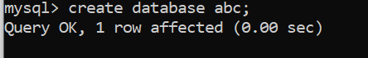

**2.Show Databases :**

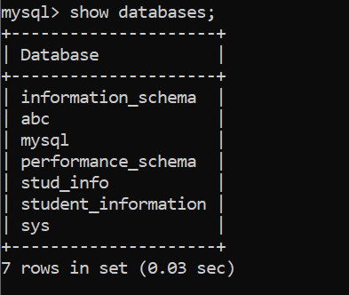



** 3. Create Table :**

**4.Insert Values :**

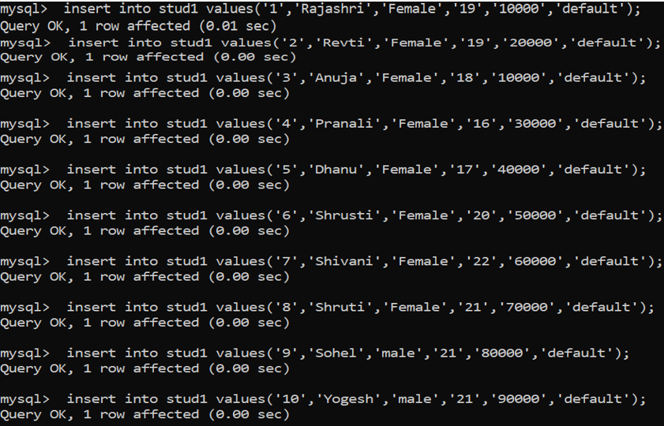

**5.Show Table :**

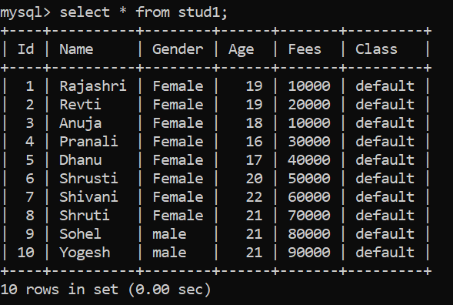

**6.Foreign Key :**

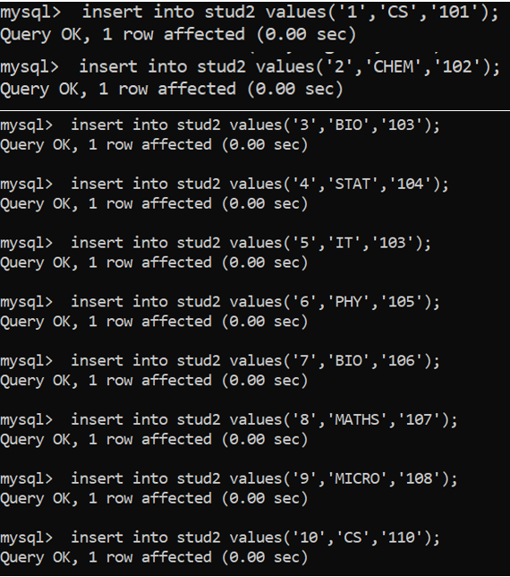

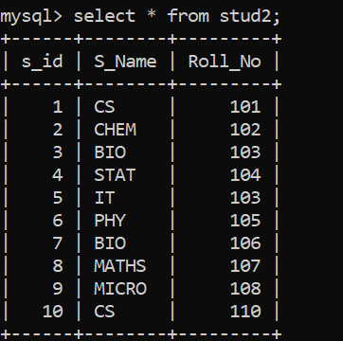

**B.Operators :**

**1] Arithmatic Operator :**

**a] Addition :**

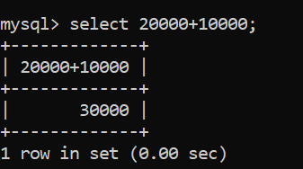

**b]. Subtraction :**

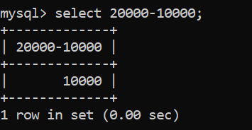

**c].Multiplication :**

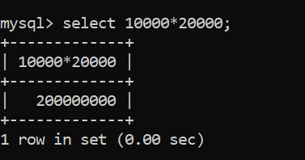

**d].Division :**

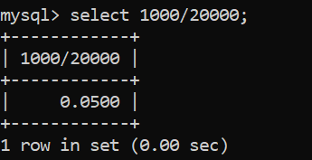

**e].Modulo Division :**

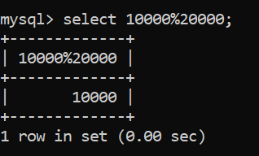

**2] Bitwise Operator :**

**a] AND :**

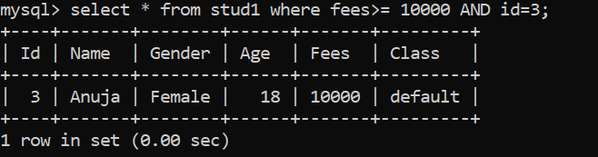

**b] OR :**

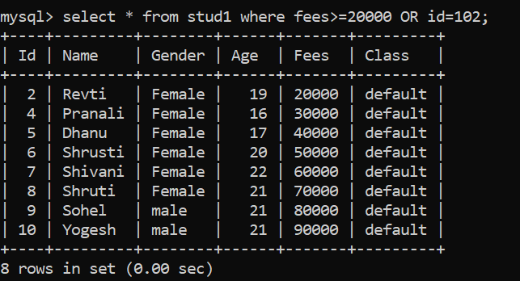

**c] XOR :**

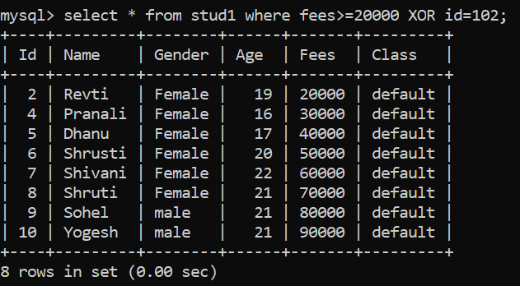

**3.Relational And Comparison Operator :**

**a] Greater than Or equal to :**

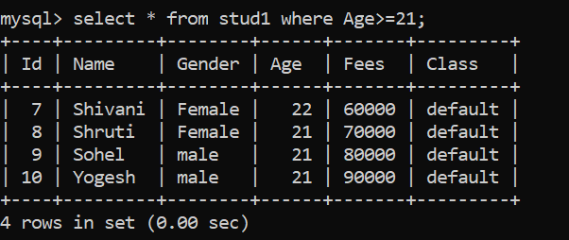

**b] Less than or equal :**

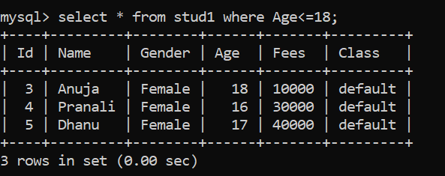

**c] Less than :**

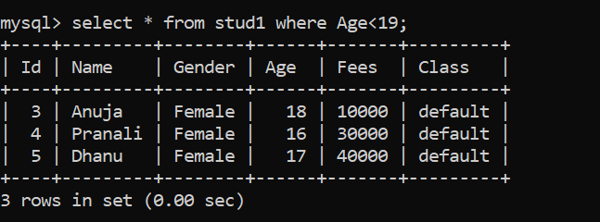

**d] Greater than :**

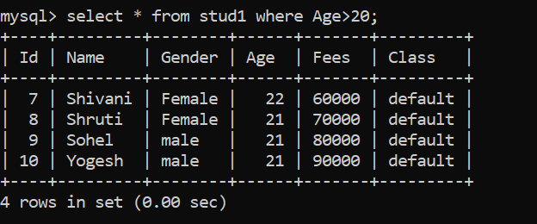

**e] Equal to :**

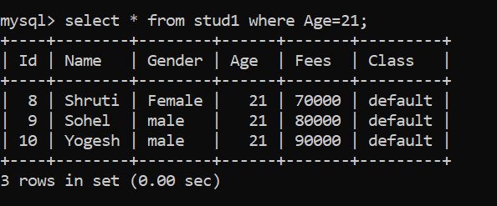

**f] Not equal to :**

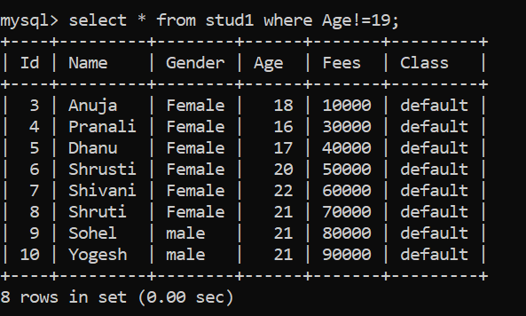

**4.Logical Operator :**

**a] Logical AND Operator :**

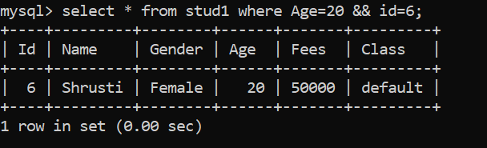

**b] Logical OR Operator :**

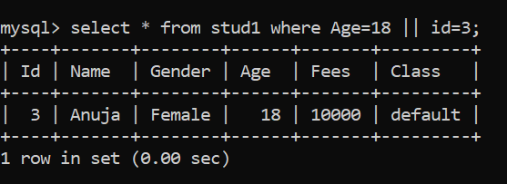

**c] Logical NOT Operator :**

